

**Most of your day is probably spent working with a smartphone. From sending emails to watching videos, from searching for work to reading the news, there are so many things that are done with a smartphone that it is almost impossible not to spend time on one of the most important pieces of technology in today's world. For this reason, the only obstacle in the way of artificial intelligence joining smartphones was the issue of time. However, as with any new technology, getting to grips with all its possibilities and greatness can potentially be overwhelming .**

**What is artificial intelligence?**

**You can think of artificial intelligence as a technology that can learn, understand, make decisions and make predictions like humans. Also known as AI , this technology began as a branch of computer science, focused on building machines that could do things like play chess or help doctors diagnose disease. But in recent years, the definition of artificial intelligence has expanded to include technologies that can learn, adapt to personal needs, and improve over time. In other words, even the most basic devices are moving towards "smartness" .**

**The most common type of artificial intelligence is** [**machine learning**](https://imhmdi.com/%d8%aa%d9%85%d8%a7%d9%85-%da%a9%d8%a7%d8%b1%d8%a8%d8%b1%d8%af%d9%87%d8%a7%db%8c-machine-learning/)**or** [**Machine Learning**](https://imhmdi.com/%db%8c%d8%a7%d8%af%da%af%db%8c%d8%b1%db%8c-%d9%85%d8%a7%d8%b4%db%8c%d9%86-machine-learning-%da%86%db%8c%d8%b3%d8%aa%d8%9f/)**It uses algorithms (short programs) to sift data and spot patterns . For example, if you use a photo app like Google Photos , the search function will get better at finding photos of your kids over time as it learns more about your collection .**

**Artificial intelligence is a broad term, as there are many different types of it. For example : Machine Learning or ML is a type of artificial intelligence that uses a computer to learn from data without specific programming. For example, it can be used to recognize your voice, identify content you might like, or drive a car .**

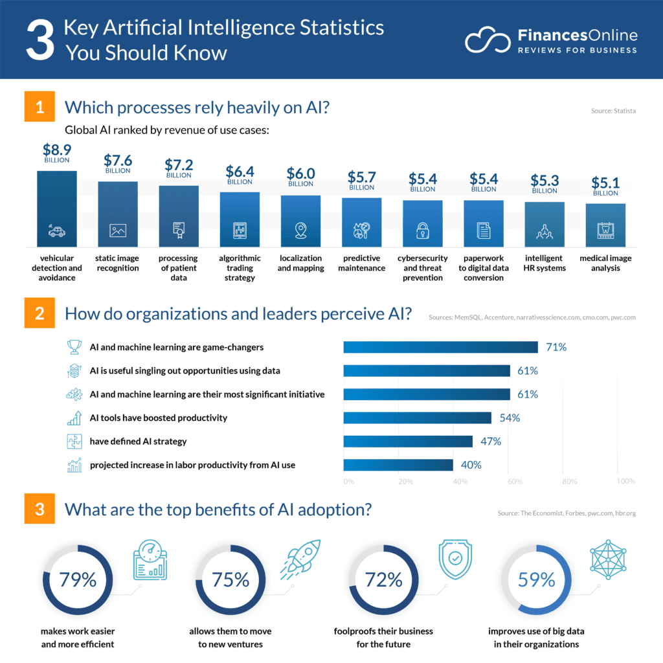**( Image source :** [**Finances Online**](https://financesonline.com/artificial-intelligence-statistics/?ref=hackernoon.com) **)**

**Why is it important?**

**The tech industry and the world rely on AI to solve big problems like cyber security, healthcare, climate change, sustainability in business management, education issues and traffic congestion. Artificial intelligence is also used in many new consumer products. Today, this technology is everywhere. From Google Home's voice recognition , which allows it to understand your requests for information, to Amazon's Alexa, which offers suggestions for watching TV, or Uber , which recommends that you download its app to get home safely .**

**The term artificial intelligence is used to describe any software that is capable of learning and solving problems like humans, whether it's Siri's voice recognition or Google's DeepMind to beat the world's best player. In other words, it's about software that uses data and algorithms to perform tasks that normally require human intelligence, such as programming,** [**speech recognition, etc.**](https://imhmdi.com/%da%86%da%af%d9%88%d9%86%d9%87-%d8%af%d8%b1-%d9%be%d8%b1%d9%88%da%98%d9%87%d9%87%d8%a7%db%8c-nlp-%d8%af%d8%a7%d8%af%d9%87-%d8%a7%d9%81%d8%b2%d8%a7%db%8c%db%8c-%da%a9%d9%86%db%8c%d9%85/)**or images and even language comprehension .**

**How fast is it growing?**

**This technology is growing rapidly. In fact, there are few senior** [**data engineers**](https://imhmdi.com/%d9%87%d9%88%d8%b4-%d9%85%d8%b5%d9%86%d9%88%d8%b9%db%8c-%d8%af%d8%a7%d8%af%d9%87-%d9%85%d8%ad%d9%88%d8%b1-%da%86%db%8c%d8%b3%d8%aa%d8%9f/) **who have the knowledge and skills to use all this data and algorithms. As a result, there is a great demand for hiring senior data engineers in all industries .**

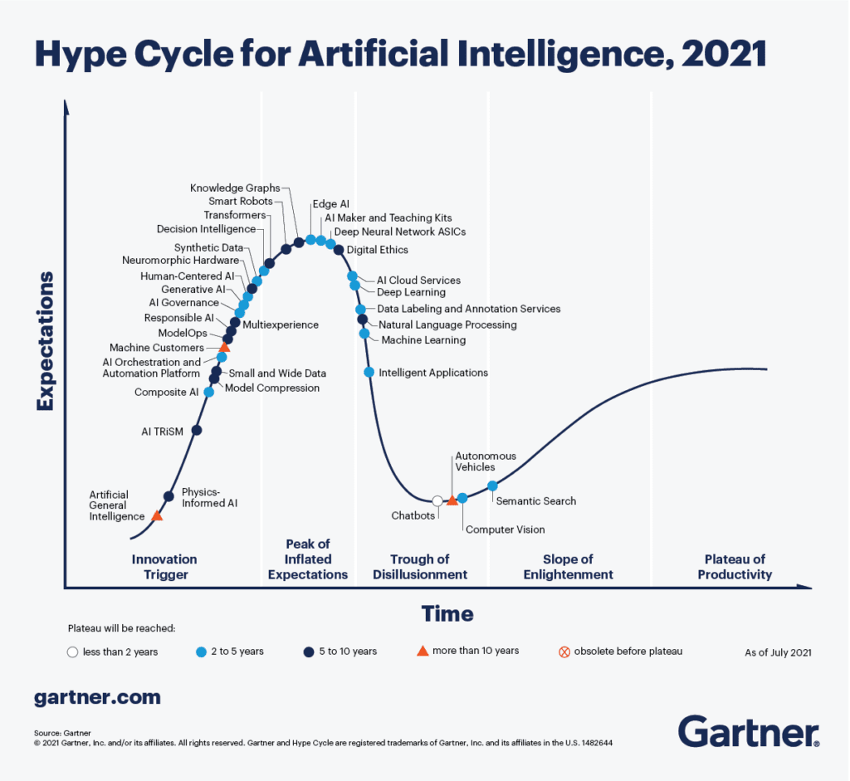**( Image source :** [**Gartner**](https://www.gartner.com/en/articles/the-4-trends-that-prevail-on-the-gartner-hype-cycle-for-ai-2021?ref=hackernoon.com) **)**

**How will artificial intelligence shape our future?**

**Artificial intelligence can make us more efficient and productive and increase our communication with each other. This is an area of research that is growing at a really fast pace and promises to have a huge impact on the private and public parts of our lives. But what can you do to make progress in this field? Here are five ways artificial intelligence will fundamentally change your life :**

**1- How can artificial intelligence make your phone smarter?**

**Have you ever wondered if the app you installed works as well as it says it does? Try Cortana , Alexa , or Google Now . All of these apps use artificial intelligence to** [**recognize people**](https://imhmdi.com/%d8%aa%d8%b4%d8%ae%db%8c%d8%b5-%da%86%d9%87%d8%b1%d9%87-%d8%af%d8%b1-%d9%87%d9%86%d8%af/) **, places, and things so they can find what you might want. You can even ask your phone to do something for you. For example, Siri can search for nearby restaurants and suggest the closest restaurant that has your favorite food on its menu. And Google Now can tell you which flights are available at the best time .**

**2- What will happen when driverless cars dominate our roads?**

**For artificial intelligence to have more useful applications, it must work in places other than laboratories and computers. One of these places is our cars. It must find its way into our cars. Various types of artificial intelligence systems have been developed to help drivers drive more safely, efficiently and productively. From self-parking cars to driver-assist cars that can recognize when their eyes are closed .**

**3- How can artificial intelligence help in solving climate change problems?**

**In order to reduce carbon emissions, we need technology that can monitor air quality and the amount of water and pollution in our aquifers and rivers. Three places that are very difficult for humans to monitor. This is why artificial intelligence doesn't just exist in science fiction anymore. Rather, it works in laboratories with databases and algorithms that are used to track information related to global water reserves .**

**4- How does artificial intelligence help us to be more productive at work, do more tasks at home and reduce our stress?**

**Researchers are currently trying to create systems that can detect when you are tired or need a break. These systems will automatically adjust your energy level at this time and if they detect that you would be more productive if you were supplemented by a machine, they will also take over some of your tasks .**

**5- How does artificial intelligence help our rebirth?**

**In the coming years, AI algorithms will give us more ways to learn and understand new things. So what next? Who knows what will happen? Maybe one day we can teach machines to learn to make us smarter and more creative .**

Amirshayan Jalili

[Shayan138190@gmail.com](mailto:Shayan138190@gmail.com)

<https://github.com/Amirshayan2002>